Recruitment Pack

Youth Worker - Programme Leader
Waltham Forest

Closing Date: 18th March

Youth Worker / Programme Leader
Full time post (option for job share).
Flexible hours, will need to be available for afternoons & evenings
Salary - £30,219 - £31,746
Applications:
Applications will only be accepted if they are on our approved form. CV’s, covering letters and email content will not be included within our shortlisting process.
When you are completing the form, please pay particular attention to the essay section which is where you can tell us how you fit the criteria listed in the person specification.
The application form can be downloaded here in either Word or PDF format. Or from our website https://worthunlimited.co.uk/jobs.
Shortlisting:
Shortlisting is carried out using a scoring system. Our recruitment panel will be looking for information in your application about how you meet the selection criteria. If you do not show us how you meet one of the “essential” criteria your application will not be taken further.
If you meet the “essential” criteria we will then look at the “important” and “desirable” criteria. Those scoring the highest across all three categories will be invited to interview.
We hope to inform those who are being invited to interview approximately two weeks after receiving your application.

Interviews:
Interviews will take place at our offices on Forest Road, Walthamstow in w/c 25th March 2024. As part of the interview you will be asked to do a 10 minute presentation on the following topic.
“What are the challenges and opportunities in working with a diverse mix of young people in Waltham Forest and how would you go about engaging and empowering young people through our projects?”
Should you have any questions about the application or process, please contact Helen Perry, at helen.perry@worthunlimited.co.uk.

What we are looking for:
We are looking for a motivated and organised person who will lead the existing programme of youth work as well as develop new projects with young people in Waltham Forest.
You will need to have relevant experience with young people aged 8 to 18 and have a qualification in Youth Work or another related field.
You will need to have an ability to relate to young people and develop positive relationships as well as experience and confidence in leading a team.
Most importantly you will be passionate about seeing young people develop their gifts, skills, talents, and character.
We care deeply about diversity in our team and encourage and welcome application from people from all backgrounds, identities, and ages. We are particularly keen to hear from those with a lived experience of the young people we support.
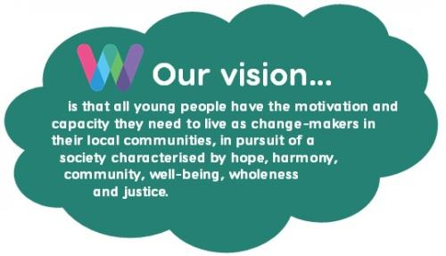
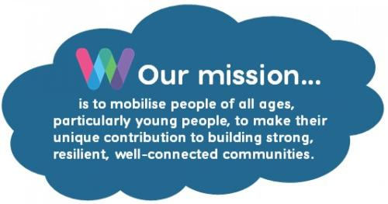

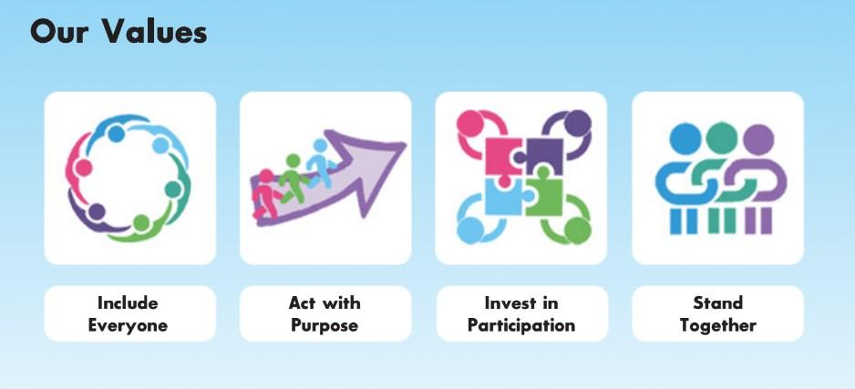

Application is by our Application Form only. CV’s will not be accepted. For further information about the job please email: helen.perry@worthunlimited.co.uk
For an application pack go to www.worthunlimited.co.uk/jobs
Worth Unlimited is a Safe Recruiter. The successful applicant will need to undergo a DBS check and have three references taken.

Closing date:
Monday 18th March 2024
Youth Worker - Programme Leader
Job Description
Purpose: To lead the existing programme of youth activities for Worth Unlimited in Waltham Forest for young people aged 8-18 years and to develop projects that help young people from areas of social deprivation develop the capacity they need to leave as changemakers in their community.
Accountability: The post holder is accountable to the Waltham Forest Branch Leader.

Hours: Full time (36.25 hours a week). Job share is a possibility subject to negotiation.

Requirements: Hours are flexible, will need to be available for afternoon/evenings and occasional weekends.

Location: Office Space at 434 Forest Office Road, E17 4PY and at various locations across the Borough of Waltham Forest.

Salary: £30,219 - £31,746

Contract: Fixed Term for 2 years with the potential to extend, subject to funding.

Duties to be undertaken:
Youth Work Delivery:
- Plan, deliver and review the youth work programme, utilising the team and taking into consideration the values and ethos of Worth Unlimited. This is primarily but not exclusively via the youth outreach van and youth clubs and is likely to include at least 6 sessions of youth work per week.
- Develop professional supportive relationships with groups of young people using a variety of approaches as appropriate.
- Work one to one with young people, formally through mentoring or informally when appropriate.
- Engage with other professionals to safeguard and increase the young people’s safety and wellbeing.
- Ensure that all work is focussed on the development of young people and measured through the Worth Unlimited Outcomes Framework.
- Contribute to initiatives and actions that increase the quality of our work with young people.
- Ensure that all monitoring records are kept as required.
- Ensure that all relevant Worth Unlimited policies are implemented throughout any work carried out including Health and Safety Policy and Child Protection Policy.

Management:
- Attend and assist in leading team meetings.
- Undertake all necessary admin tasks for programme related activities (i.e. risk assessments, communications, etc).
- Assist in the recruitment of volunteers, and provide informal support as needed.
- Assist in budget monitoring for projects that are being led.
- Deputise for the Branch Leader when needed (for example for sickness or holiday cover).

Strategic:
- Make contact with, build knowledge of, and develop professional working relationships with other local agencies likely to include the Police, the local Youth Service, Teachers, Learning Mentors, Local Community Networks, other youth providers, and the local faith communities, in order to promote and advocate on behalf of the branch and build positive partnerships that bring better opportunities for young people.
- Contribute to the development and implementation of the overall strategy of the Waltham Forest Branch.
- Help identify suitable funding opportunities and prepare funding applications.

Other:
- Be involved in the promotion of Worth Unlimited both in Waltham Forest and nationally. This includes initiating and contributing to fundraising initiatives and events.
- Participate in national Worth Unlimited events and initiatives as required, including attending the annual Worth Gathering event.
- Undertake training and development relevant to your role.
- Meet regularly with the Branch Leader/Manager for managerial supervision.
- Any other relevant tasks as directed by the Branch Leader.
Person Specification - Youth Worker - Programme Leader

A person suitable for this post will be able to show the following…
Factor | Essential | Important | Desirable
Skills | - Ability to relate to young people and develop positive relationships  - Ability to establish and maintain positive working relationships with other professionals and agencies  - Excellent communication skills  - Ability to understand and work within professional and personal boundaries  - Good personal organisation  - Literacy and numeracy skills sufficient to assist young people and keep records  - Ability to plan and deliver projects and activities
Attitude/ approach | - A positive outlook  - Patient  - Accepting/non-judgmental/understanding  - Flexibility  - Willing to work within our Christian ethos and values | - Enthusiastic nature  - Persistence to follow up issues
Experience |  | - Working with young people in a variety of different contexts  - Working in partnership with a range of agencies  - Working with young people with challenging behaviour  - Developing projects from planning to delivery stages | - Experience of working in urban city environments
Knowledge | - Understanding of issues relating to safeguarding and child protection. | - Understanding of issues involved in working with young people from different cultural backgrounds  - Understanding of empowering and participative approaches to working with young people | - Understanding of Mentoring processes
Equal Opportunities | - Commitment to anti-discriminatory practice | - Understanding of issues relating to equal opportunities and able to apply these to real situations and contexts
Education & Training | - Qualification in Youth Work or directly related field, at further education level | - Qualification in Youth Work or directly related field, at higher education level | - Degree level JNC recognised course
Other | - Able to undertake evening work and occasional weekend |  | - Full UK Driving License  - Available for occasional overnight residentials  - Able to drive a minibus (License and MIDAS training)

